

**THE COMMITTEE FOR SYDNEY INCORPORATED**

**NOTICE OF SPECIAL GENERAL MEETING OF MEMBERS**

Notice is given that a special general meeting of the Committee for Sydney Incorporated (the "**Committee**") will be held at 3.00pm on Tuesday, 13 December 2022 via Zoom.

SPECIAL BUSINESS

To adopt changes to the Committee’s Constitution.

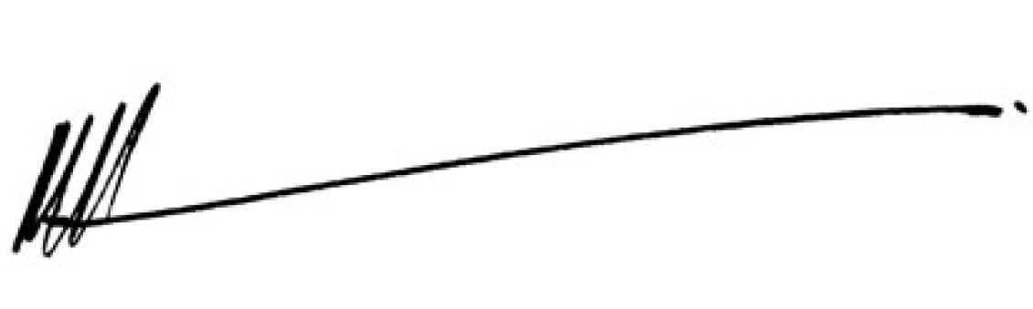

Michael Rose

Chairman

**NOTES:**

**Who may vote** Persons whose names are set out in the Committee’s register of members at the time of the meeting are entitled to attend and vote at the meeting convened by this notice.

**Proxies - Appointment** A Member of the Committee who is entitled to attend and vote at the meeting through its Representative may appoint another person as their proxy.

**Proxies - Lodgement** To be valid, a proxy form must be received by the Secretary no later than 1 hour before the time of the meeting using the form attached to this meeting notice. Proxies may be submitted:

(a) in person to the Secretary;

(b) by email: [committee@sydney.org.au](mailto:committee@sydney.org.au)



**SPECIAL RESOLUTION OF MEMBERS**

**Item of Business – Amendment to the Constitution**

To consider and if thought fit, pass the following resolution as a special resolution:

That the Constitution of the Committee for Sydney (**Constitution**) be amended as per the identified changes in Attachment 1.



**Explanatory Notes**

**Item of Business – Amendment to the Constitution**

Following a review of the Committee's Constitution, the Executive Committee is recommending to Members that changes be incorporated to assist with the future growth of the Committee.

The proposed changes simplify the Objects and speak more directly to the research we do, in order to maximise the Committee's chances of being designated as an Approved Research Institute by the Australian Taxation Office (ATO). This would open the door to receiving Deductible Gift Recipient (DGR) Status and create new pathways to fund research.

Having reviewed the “purposes” of similar organisations such as the Grattan Institute, we believe we can do this in a way that is entirely consistent with our longstanding scope of activities.

These changes do not change the activity of the Committee or its membership structure.

If we are approved by the ATO, we would establish a process for separately allocating and managing tax deductible gifts, as per ATO guidelines. This would include:

* Research Committee and financial structure to manage and report on donations.
* Establishing a Research Committee of five suitably qualified people. This group would be responsible for allocating the tax-deductible funds to specific projects and ensuring they are spent in accordance with eligible research purposes. Atilla Brungs, Vice Chancellor of UNSW and CFS Board member, has agreed to chair the Research Committee.
* The Research Committee would meet as needed to review a program nominated by the Committee for Sydney Executive Committee and to give substantive support to research projects.
* A separate account to manage and track DGR donations will also need to be established.

A copy of the Constitution, highlighting the proposed changes, is provided in [Attachment 1](https://sydney.org.au/wp-content/uploads/2022/10/CFS-Constitution-Compare-to-original-August-2022.pdf).

A clean copy of the Constitution (as amended) is provided in [Attachment 2.](https://sydney.org.au/wp-content/uploads/2022/10/CFS-Constitution-August-2022.pdf)

**FORM OF APPOINTMENT OF PROXY**

I ……………………………………………… of ………………………………………………… being a Member of Committee for Sydney Incorporated hereby appoint  
………………………………………………………………………………………………………….  
as my proxy to vote for me on my behalf at the special general meeting of the Committee to be held on the 13th day of December 2022 and at any adjournment of that meeting.

My proxy is authorised to vote on my behalf in relation to the resolution put before the above meeting on which I am entitled to vote.

Signed

Date